**Topics: Normal distribution, Functions of Random Variables**

1. The time required for servicing transmissions is normally distributed with *μ* = 45 minutes and *σ* = 8 minutes. The service manager plans to have work begin on the transmission of a customer’s car 10 minutes after the car is dropped off and the customer is told that the car will be ready within 1 hour from drop-off. What is the probability that the service manager cannot meet his commitment?
2. 0.3875
3. 0.2676
4. 0.5
5. 0.6987

**Ans:**

Given:-

*μ* = 45 min

*σ* = 8 min

Probability that the service manager cannot meet his commitment is

P(X > 50) = 1 – P(X <= 50) == > 0.266

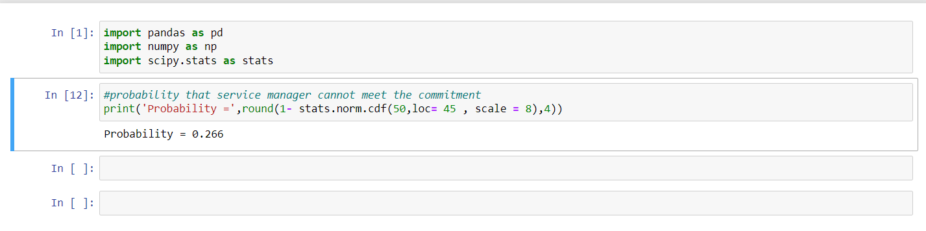

1. The current age (in years) of 400 clerical employees at an insurance claims processing center is normally distributed with mean *μ* = 38 and Standard deviation *σ* =6. For each statement below, please specify True/False. If false, briefly explain why.
2. More employees at the processing center are older than 44 than between 38 and 44.
3. A training program for employees under the age of 30 at the center would be expected to attract about 36 employees.

**Ans:**

Given:

*μ* = 38,

*σ* =6,

1. 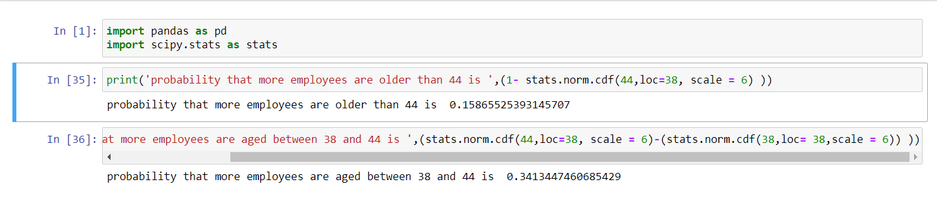As we can see, the population within the age group 38 and 44 is 34.13% , whereas the population older than 44 is only 15.86%. Therefore, the statement “More employees at the processing center are older than 44 than between 38 and 44” is **FALSE.**

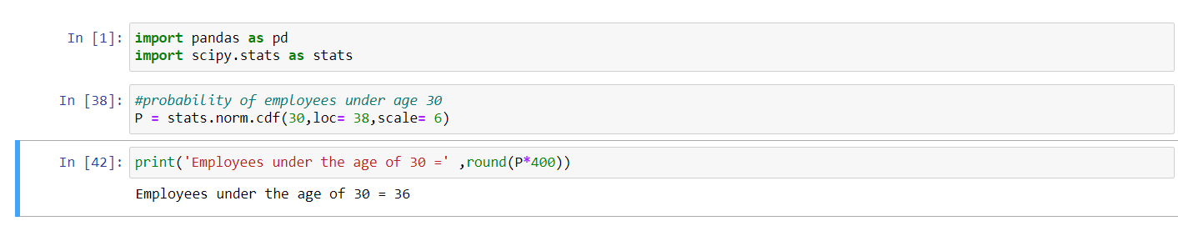

The number of people below age 30 = P(X<30) * 400

The statement “A training program for employees under the age of 30 at the center would be expected to attract about 36 employees” is **TRUE.**

1. If *X1* ~ *N*(μ, σ2) and *X*2 ~ *N*(μ, σ2) are *iid* normal random variables, then what is the difference between 2 *X*1 and *X*1 + *X*2? Discuss both their distributions and parameters.

**Ans:**

We know that,

If, X ∼ N(µ1, σ1^2 )

Y ∼ N(µ2, σ2^2 ) are two independent random variables

Then,

X + Y ∼ N(µ1 + µ2, σ1^2 + σ2^2 )

X − Y ∼ N(µ1 − µ2, σ1^2 + σ2^2 )

Similarly,

Z = aX + bY , where X and Y are as defined above, i.e Z is linear combination of X and Y, then Z ∼ N(aµ1 + bµ2, a^2σ1^2 + b^2σ2^2 ).

Therefore, in the question

2X1 ~ N(2 µ,4 σ^2)

And X1+X2 ~ N(µ + µ, σ^2 + σ^2 ) ~ N(2µ, 2σ^2 ) 2X1-(X1+X2)

= N( 4µ,6 σ^2).

1. Let X ~ N(100, 202). Find two values, *a* and *b*, symmetric about the mean, such that the probability of the random variable taking a value between them is 0.99.
2. 90.5, 105.9
3. 80.2, 119.8
4. 22, 78
5. **48.5, 151.5**
6. 90.1, 109.9

**Ans:**

Given:

**

1. Consider a company that has two different divisions. The annual profits from the two divisions are independent and have distributions Profit1 ~ N(5, 32) and Profit2 ~ N(7, 42) respectively. Both the profits are in $ Million. Answer the following questions about the total profit of the company in Rupees. Assume that $1 = Rs. 45
2. Specify a Rupee range (centered on the mean) such that it contains 95% probability for the annual profit of the company.
3. Specify the 5th percentile of profit (in Rupees) for the company
4. Which of the two divisions has a larger probability of making a loss in a given year?

**Ans:**

Given:

Profit1 ~ N(5, 32)

Profit2 ~ N(7, 42)

Thus, company’s profit :-

P ~ N(5+7 , 32+ 42) = N(12 , 25) = N(12, 52)

**A**.

**B.**

Formula to calculate the 5th percentile :

**X = μ + Zσ**

**C.**

